**Week 2-Assignment -2**

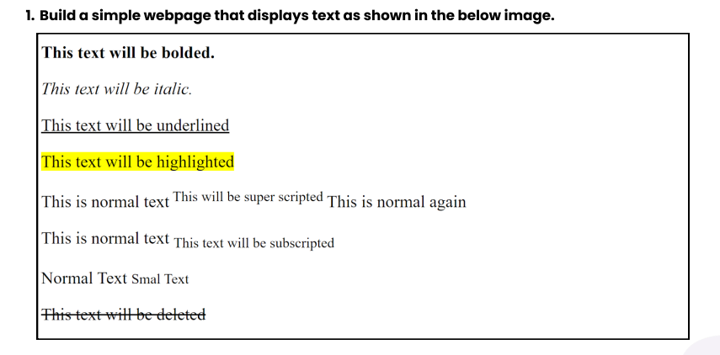

<!DOCTYPE html>

<html lang="en">

<head>

    <meta charset="UTF-8">

    <meta name="viewport" content="width=device-width, initial-scale=1.0">

    <title>assignmnet-2</title>

</head>

<body>

   <b>This text wil be bolded.</b><br><br>

   <em>This text will be italic.</em><br><br>

   <u>This text will be underlined</u><br><br>

   <mark>This text will be highlighted</mark><br>

   <p>This is a normal text<sup>This text will be super scripted </sup> This is normal again</p>

   <p>This is a normal text<sub>This text will be subscripted </sub></p>

   <p>Normal Text <small>Small Text</small></p>

   <del>This text will be deleted</del>

</body>

</html>

**Output:**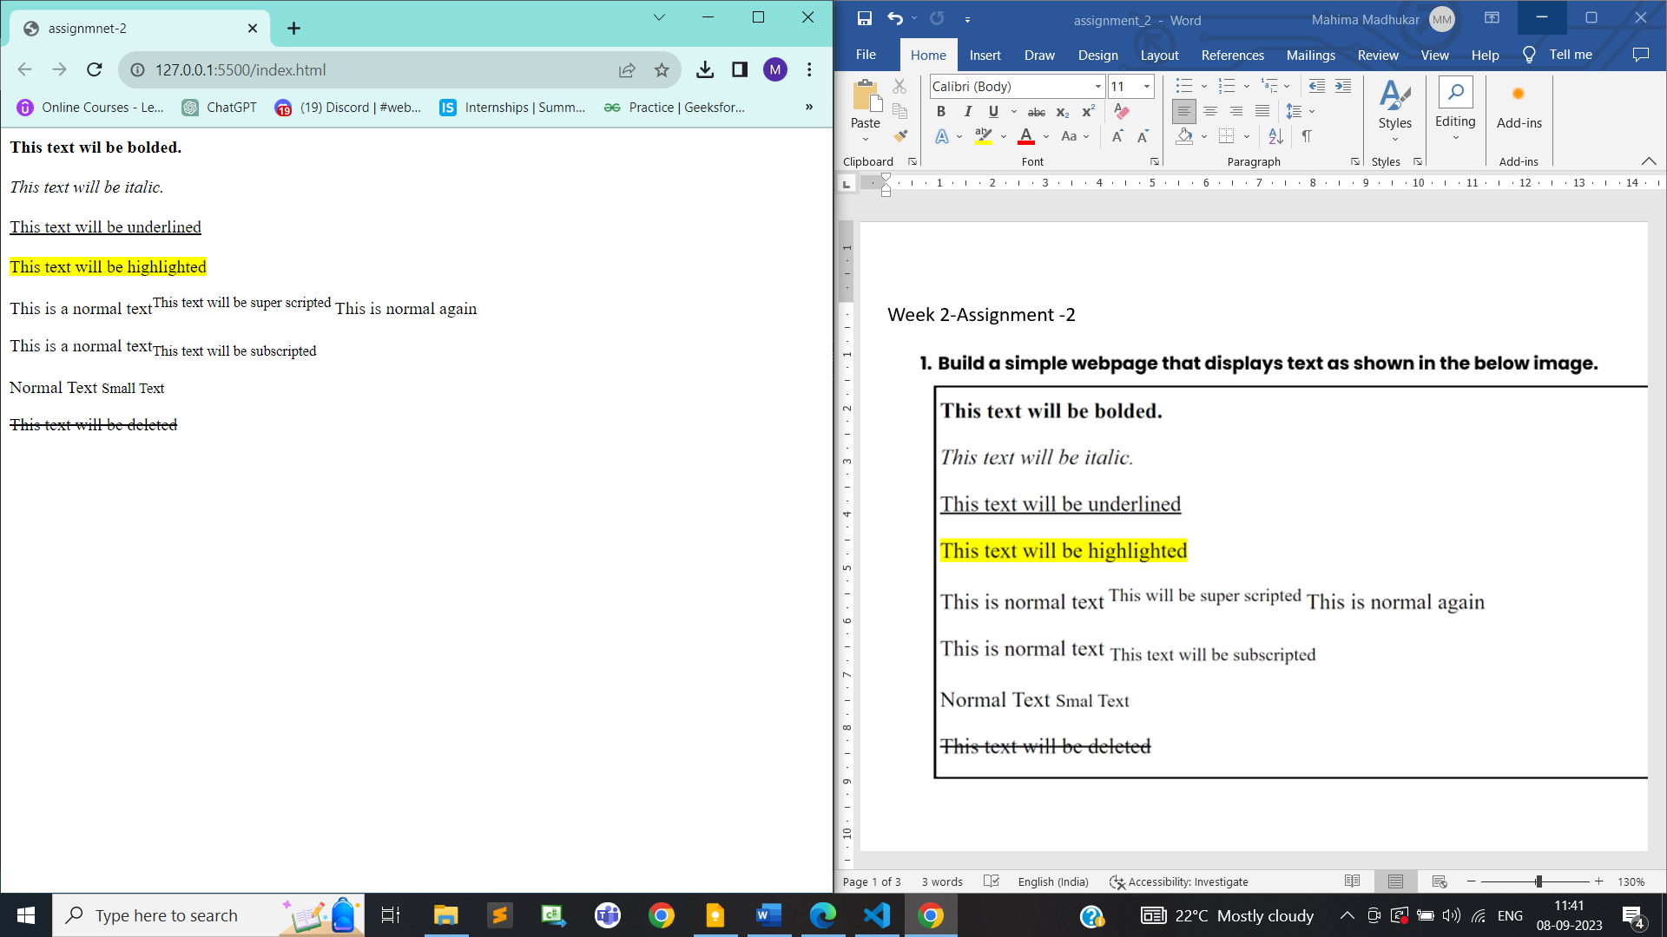

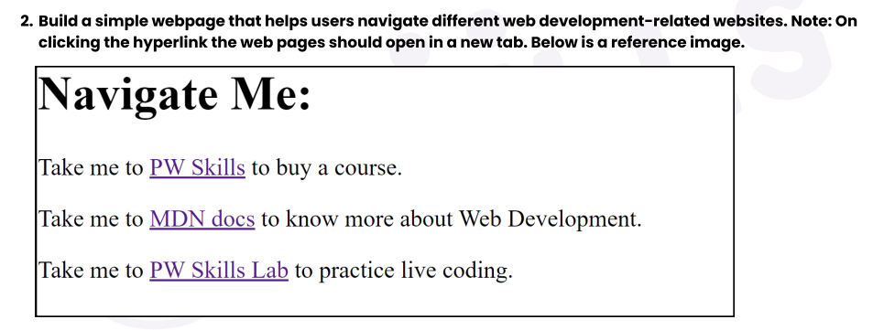

<!DOCTYPE html>

<html lang="en">

<head>

    <meta charset="UTF-8">

    <meta name="viewport" content="width=device-width, initial-scale=1.0">

    <title>assignmnet-2</title>

</head>

<body>

   <h1>Navigate Me:</h1>

   <p>Take me to <a href="https://pwskills.com/" target="_blank">PW Skills</a> to buy a course</p>

   <p>Take me to <a href="https://developer.mozilla.org/en-US/" target="_blank">MDN docs</a> to know more about Web Development</p>

   <p>Take me to <a href="https://lab.pwskills.com/%2F" target="_blank">PW Skills Lab</a> to practice live coding</p>

</body>

</html>

**Output:**

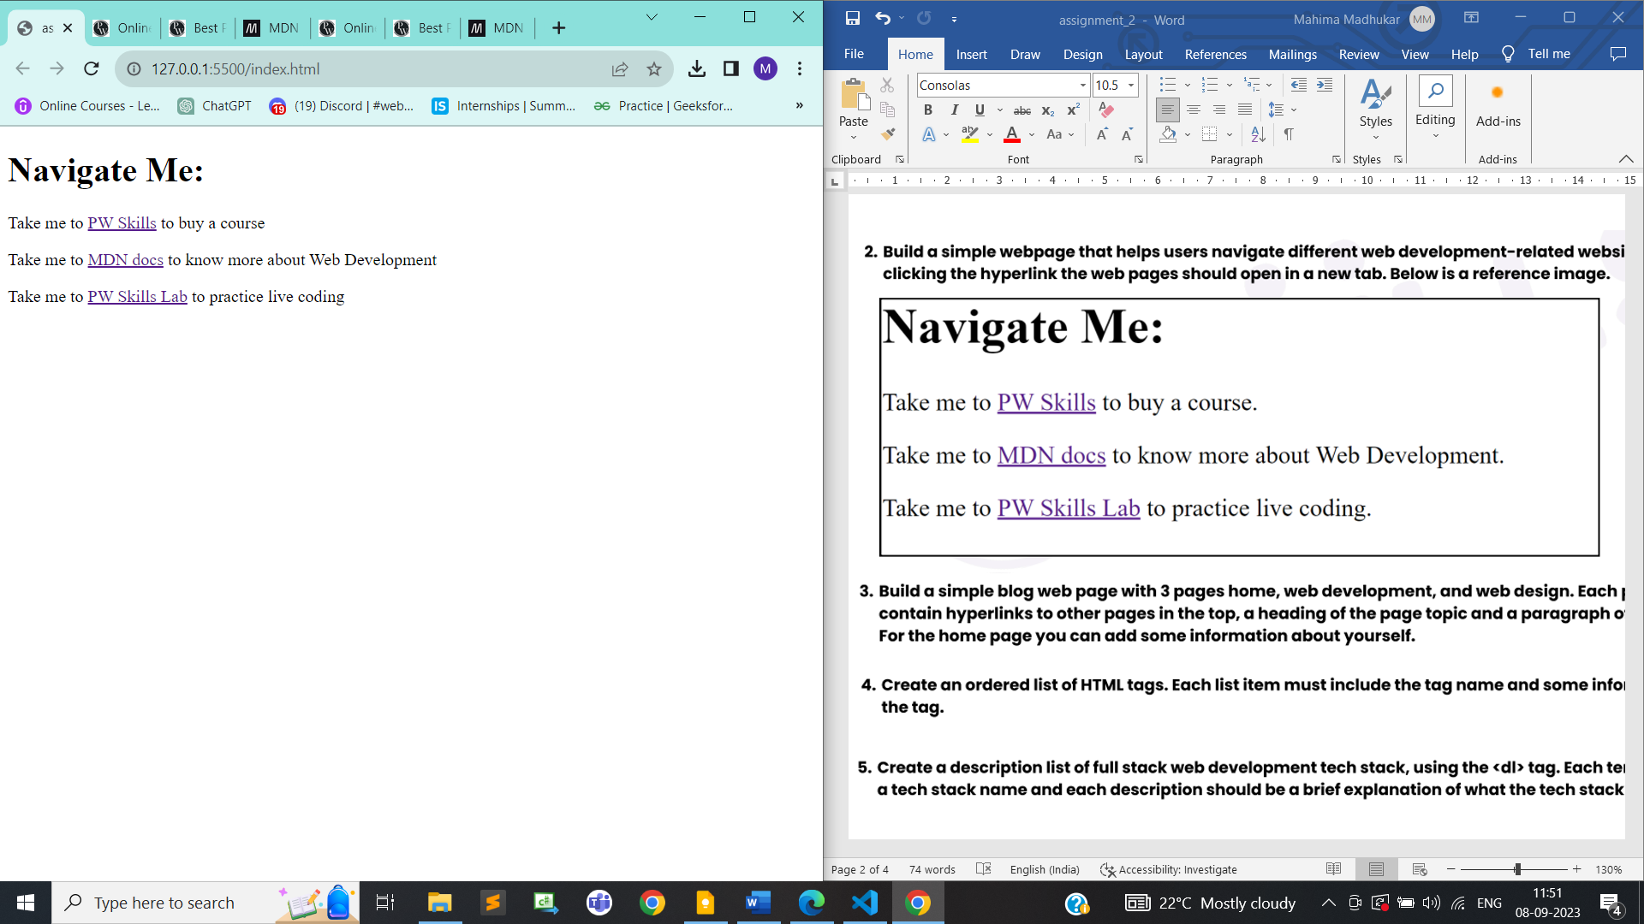



**Index.html**

<!DOCTYPE html>

<html lang="en">

<head>

    <meta charset="UTF-8">

    <meta name="viewport" content="width=device-width, initial-scale=1.0">

    <title>Home</title>

    <style>

        li{

            display: inline;

        }

    </style>

</head>

<body>

    <header>

        <nav>

            <ul style="list-style-type: none;">

                <li><a href="index.html">Home</a></li>

                <li><a href="web-development.html">Web Development</a></li>

                <li><a href="web-design.html">Web Design</a></li>

            </ul>

        </nav>

    </header>

    <main>

        <h1>Welcome to My Blog</h1>

        <p>Hi, I'm Mahima. This is my blog where I share my thoughts on web development and web design.</p>

    </main>

</body>

</html>

**Web-development.html**

<!DOCTYPE html>

<html lang="en">

<head>

    <meta charset="UTF-8">

    <meta name="viewport" content="width=device-width, initial-scale=1.0">

    <title>Web development</title>

    <style>

        li{

            display: inline;

        }

    </style>

</head>

<body>

    <header>

        <nav>

            <ul style="list-style-type: none;">

                <li><a href="index.html">Home</a></li>

                <li><a href="web-development.html">Web Development</a></li>

                <li><a href="web-design.html">Web Design</a></li>

            </ul>

        </nav>

    </header>

    <main>

        <h1>Web Development</h1>

        <p>In this section, you'll find articles and resources related to web development, including programming languages, frameworks, and best practices.</p>

    </main>

</body>

</html>

**web-design.html**

<!DOCTYPE html>

<html lang="en">

<head>

    <meta charset="UTF-8">

    <meta name="viewport" content="width=device-width, initial-scale=1.0">

    <title>web-design</title>

    <style>

        li{

            display: inline;

        }

    </style>

</head>

<body>

    <header>

        <nav>

            <ul style="list-style-type: none;">

                <li><a href="index.html">Home</a></li>

                <li><a href="web-development.html">Web Development</a></li>

                <li><a href="web-design.html">Web Design</a></li>

            </ul>

        </nav>

    </header>

    <main>

        <h1>Web Design</h1>

        <p>Explore articles and tips related to web design, including user experience (UX), user interface (UI), and design principles.</p>

    </main>

</body>

</html>

**Output:**

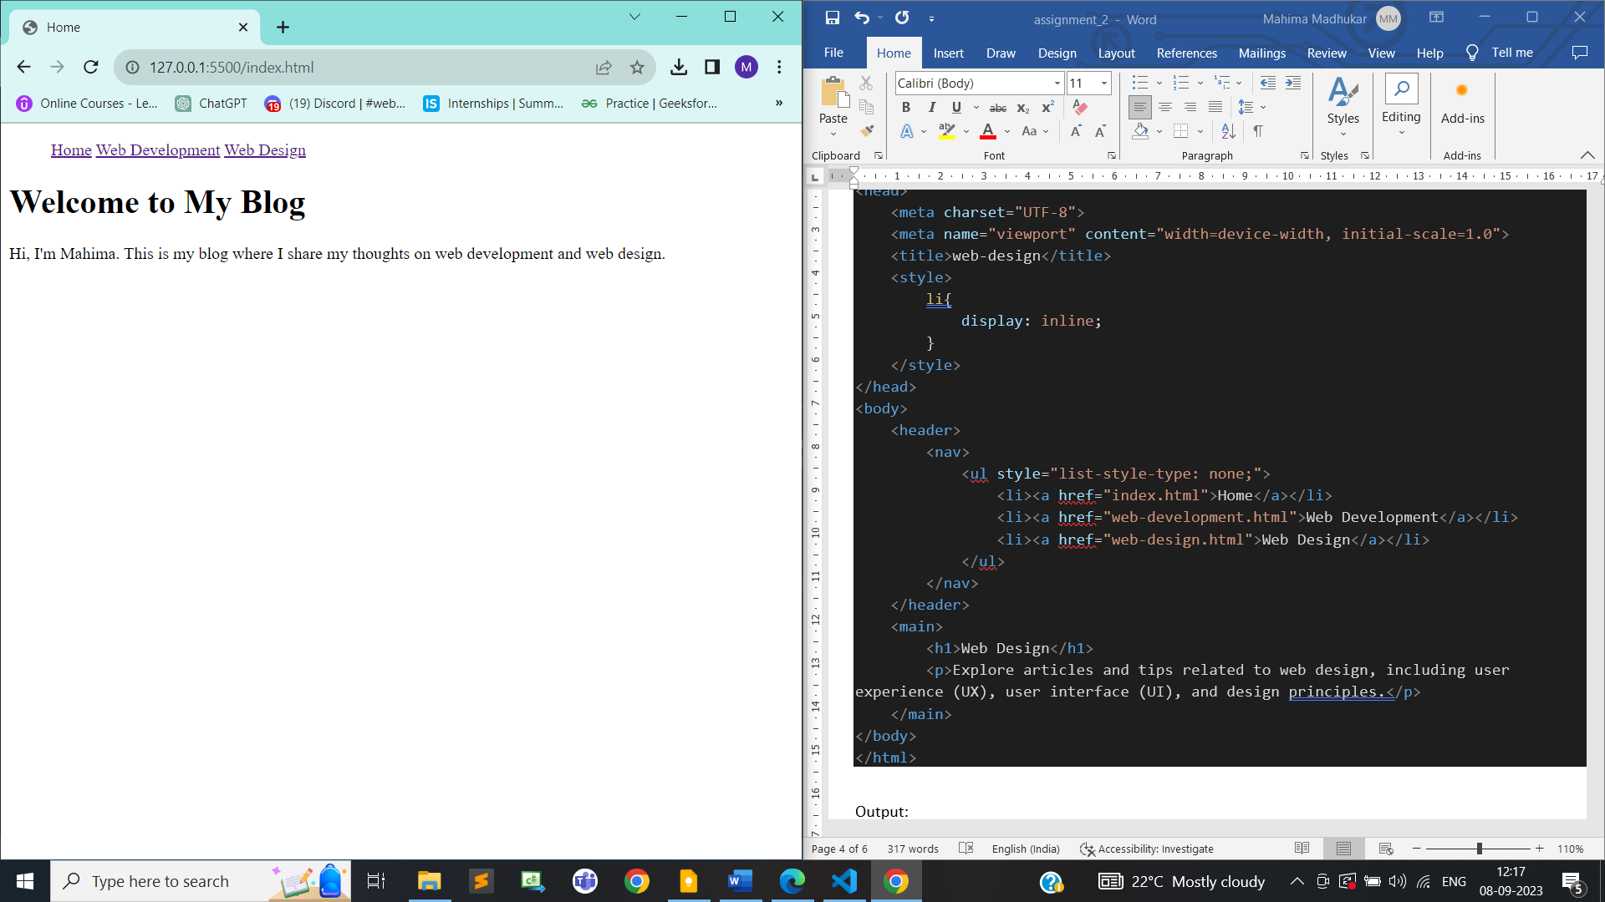

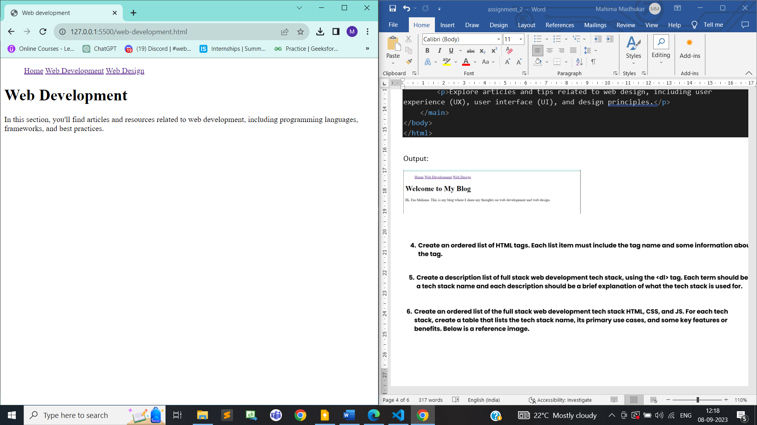

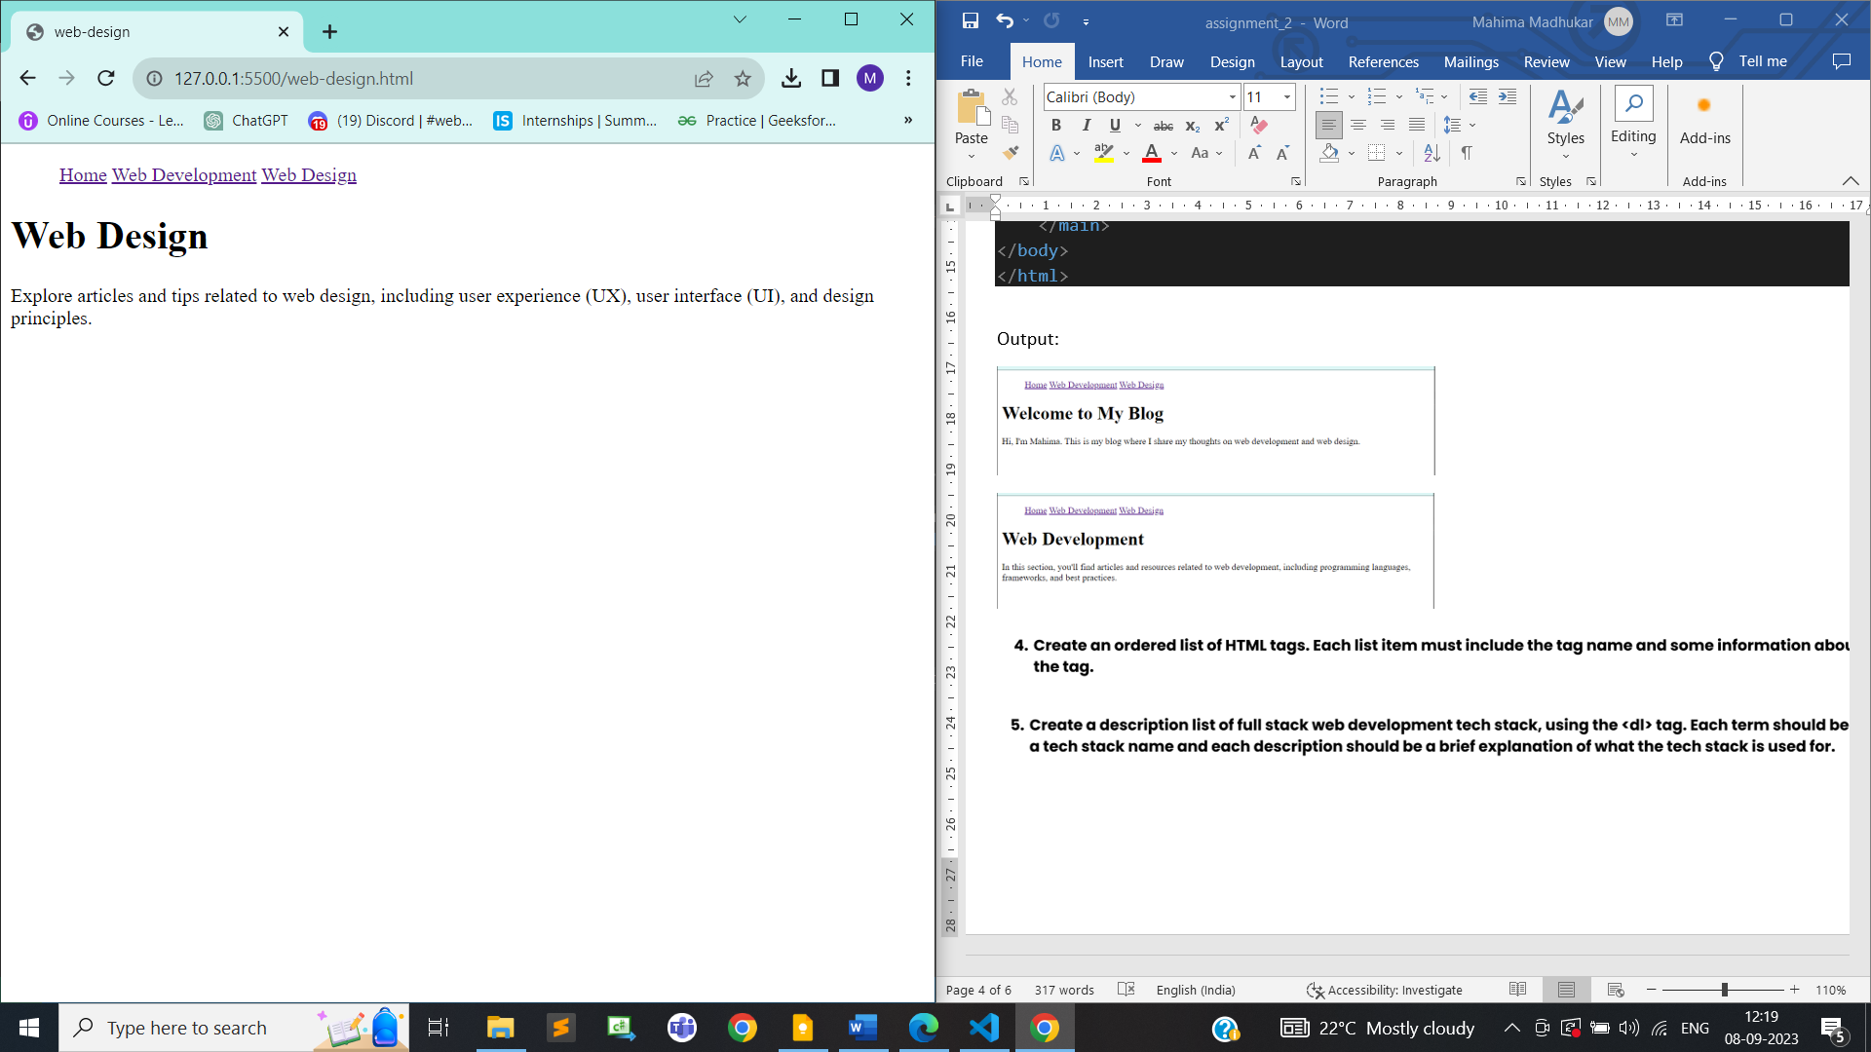



<!DOCTYPE html>

<html lang="en">

<head>

    <meta charset="UTF-8">

    <meta name="viewport" content="width=device-width, initial-scale=1.0">

    <title>assignment -2 ordered-list</title>

</head>

<body>

    <ol>

        <li>

            <strong>&lt;html&gt;</strong>: The root element of an HTML document. It contains all other HTML elements and is usually paired with a closing &lt;/html&gt; tag.

        </li>

        <li>

            <strong>&lt;head&gt;</strong>: Contains meta-information about the HTML document, such as the title, character set, and linked stylesheets.

        </li>

        <li>

            <strong>&lt;title&gt;</strong>: Sets the title of the HTML document, which is displayed in the browser's title bar or tab.

        </li>

        <li>

            <strong>&lt;body&gt;</strong>: Contains the main content of the HTML document, including text, images, links, and other elements.

        </li>

        <li>

            <strong>&lt;h1&gt;</strong> to <strong>&lt;h6&gt;</strong>: Heading elements for defining various levels of headings, with &lt;h1&gt; being the highest level and &lt;h6&gt; the lowest.

        </li>

        <li>

            <strong>&lt;p&gt;</strong>: Represents a paragraph of text or content.

        </li>

        <li>

            <strong>&lt;a&gt;</strong>: Defines a hyperlink that can link to another web page or resource.

        </li>

        <li>

            <strong>&lt;img&gt;</strong>: Embeds an image in the HTML document.

        </li>

        <li>

            <strong>&lt;ul&gt;</strong>: Creates an unordered (bulleted) list of items.

        </li>

        <li>

            <strong>&lt;ol&gt;</strong>: Creates an ordered (numbered) list of items.

        </li>

        <li>

            <strong>&lt;li&gt;</strong>: Represents a list item within an &lt;ul&gt; or &lt;ol&gt; element.

        </li>

        <li>

            <strong>&lt;div&gt;</strong>: A generic container for grouping and styling elements.

    </ol>

</body>

</html>

**Output:**

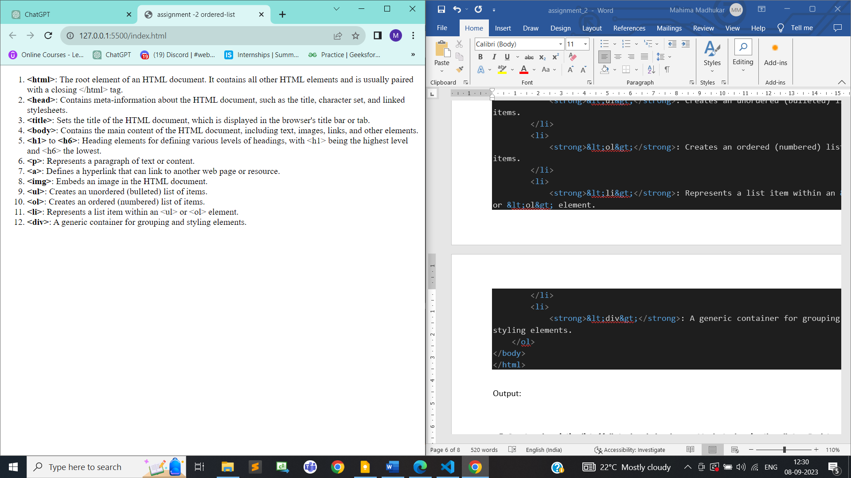

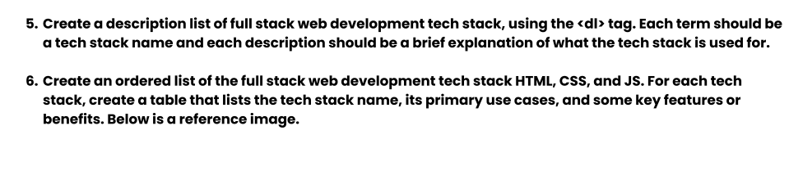

<!DOCTYPE html>

<html lang="en">

<head>

    <meta charset="UTF-8">

    <meta name="viewport" content="width=device-width, initial-scale=1.0">

    <title>assignment -2 Full stack web dev</title>

</head>

<body>

    <h1>Full Stack Web Development Tech Stack</h1>

    <dl>

        <dt>HTML/CSS</dt>

        <dd>HTML (Hypertext Markup Language) and CSS (Cascading Style Sheets) are fundamental technologies for building the structure and styling of web pages.</dd>

        <br>

        <dt>JavaScript</dt>

        <dd>JavaScript is a  scripting language used for client-side interactivity, enabling dynamic content, form validation, and more.</dd>

        <br>

        <dt>Node.js</dt>

        <dd>Node.js is a server-side JavaScript runtime used for building scalable and fast network applications, including web servers.</dd>

        <br>

        <dt>Express.js</dt>

        <dd>Express.js is a minimal and flexible Node.js web application framework that simplifies the development of server-side applications and APIs.</dd>

        <br>

        <dt>React</dt>

        <dd>React is a popular JavaScript library for building user interfaces, making it easier to create interactive and responsive web applications.</dd>

        <br>

        <dt>Angular</dt>

        <dd>Angular is a comprehensive front-end framework for building dynamic and data-driven web applications with a focus on modularity and testing.</dd>

        <br>

        <dt>Vue.js</dt>

        <dd>Vue.js is a progressive JavaScript framework used for building user interfaces, offering a flexible and approachable design.</dd>

        <br>

        <dt>SQL/NoSQL</dt>

        <dd>SQL databases (e.g., MySQL, PostgreSQL) and NoSQL databases (e.g., MongoDB) are used to store and manage data in web applications, each with its own strengths.</dd>

        <br>

        <dt>RESTful APIs</dt>

        <dd>Representational State Transfer (REST) is an architectural style used to design APIs for web applications, enabling communication between the client and server.</dd>

        <br>

        <dt>Git</dt>

        <dd>Git is a distributed version control system used for tracking changes in code and collaborating with other developers.</dd>

    </dl>

</body>

</html>

**Output:**

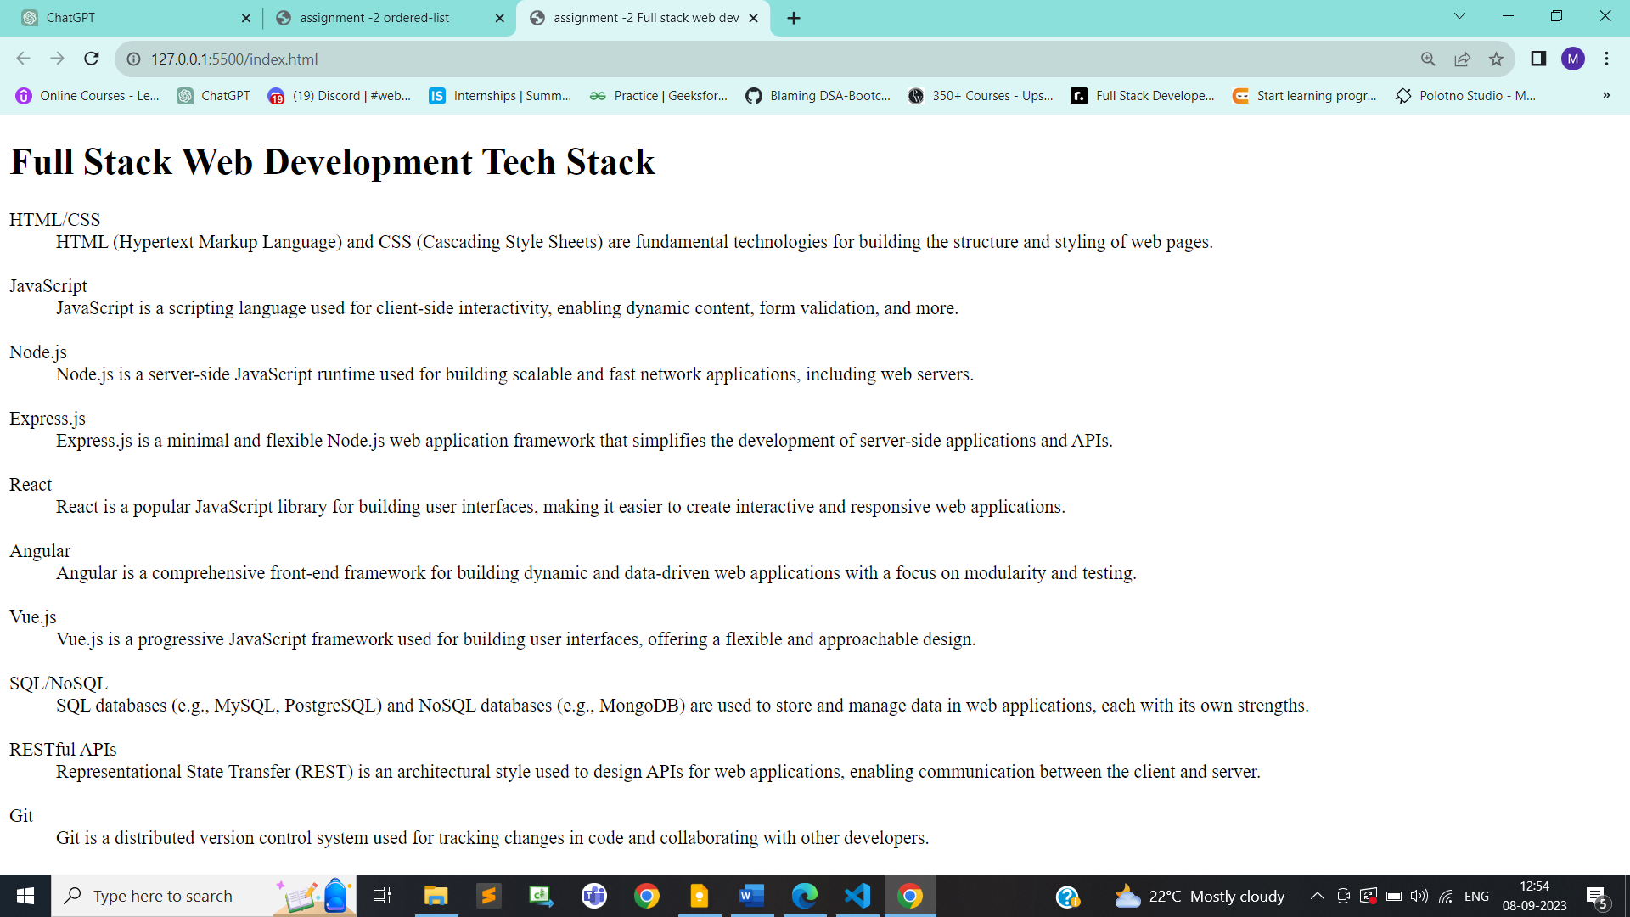



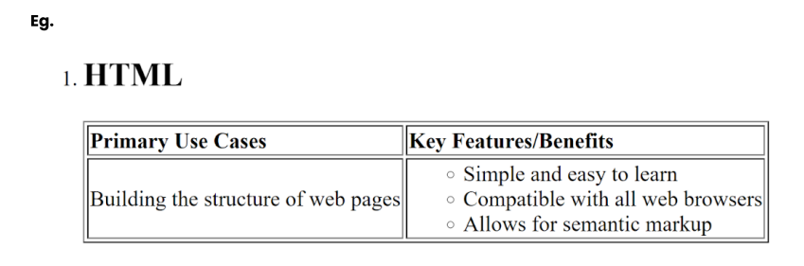

<!DOCTYPE html>

<html lang="en">

<head>

    <meta charset="UTF-8">

    <meta name="viewport" content="width=device-width, initial-scale=1.0">

    <title>assignment -2</title>

</head>

<body>

    <h2>Full Stack Web Development Tech Stack HTML,CSS,JS</h2>

    <ol>

        <li>HTML</li>

        <table border="1">

            <tr>

                <th>Primary Use cases</th>

                <th>Key Features/Benefits</th>

            </tr>

            <tr><td>building the structure of webpage</td>

                <td>

                    <ul>

                        <li>simple and easy to learn</li>

                        <li>compatible with all web browsers</li>

                        <li>Allows for sementic markup</li>

                    </ul>

                </td>

            </tr>

        </table>

        <br>

        <li>CSS</li>

        <table border="1">

            <tr>

                <th>Primary Use cases</th>

                <th>Key Features/Benefits</th>

            </tr>

            <tr><td>styling  web pages</td>

                <td>

                    <ul>

                        <li>Selective styling</li>

                        <li>Consistency and reusability</li>

                        <li>Improved user experience</li>

                    </ul>

                </td>

            </tr>

        </table>

        <br>

        <li>JS</li>

        <table border="1">

            <tr>

                <th>Primary Use cases</th>

                <th>Key Features/Benefits</th>

            </tr>

            <tr><td>Brings interactivity to web pages</td>

                <td>

                    <ul>

                        <li>Cross-Browser Compatibility</li>

                        <li>Dynamic Content Updates</li>

                        <li>Extensive Library Ecosystem</li>

                    </ul>

                </td>

            </tr>

        </table>

    </ol>

</body>

</html>

**Output:**

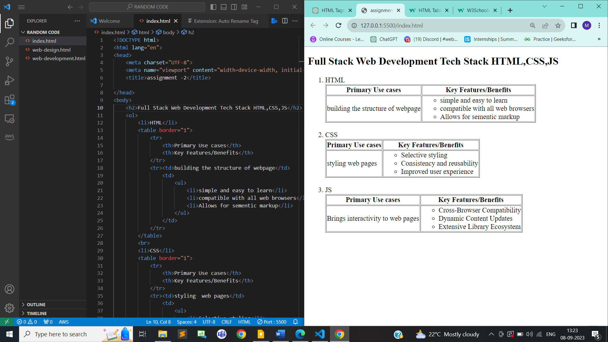

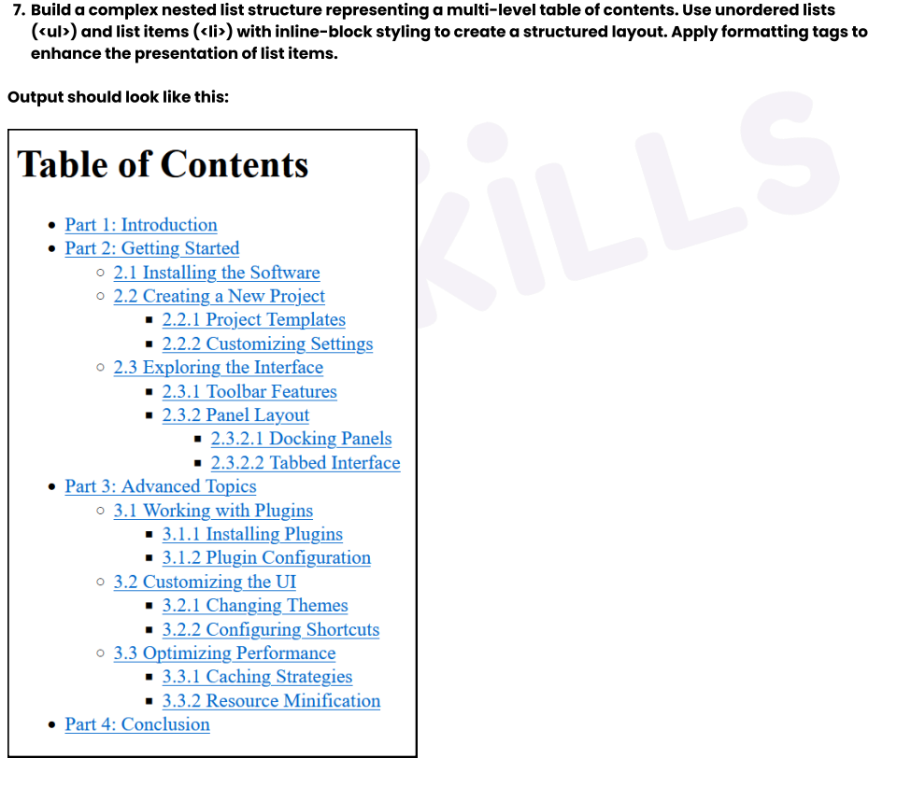

<!DOCTYPE html>

<html lang="en">

<head>

    <meta charset="UTF-8">

    <meta name="viewport" content="width=device-width, initial-scale=1.0">

    <title>assignment -2</title>

   <style>

    ul{

        margin: 0;

    }

    u {

        color: rgb(12, 142, 234);

        font-weight:bold;

    }

   </style>

</head>

<body>

    <h2>Table of Contents</h2>

    <ul><li><u>Part1: Introduction</u></li></ul>

    <ul><li><u>Part2: Getting Started</u></li>

    <ul>

        <li><u>2.1 Installing the Software</u></li>

        <li><u>2.2 Creating a New Project</u>

        <ul>

            <li><u>2.2.1 Project Templates</u></li>

            <li><u>2.2.2 Customising Settings</u></li>

        </ul></li>

        <li><u>2.3 Exploring the interface</u>

        <ul>

            <li><u>2.3.1 Toolbar features</u></li>

            <li><u>2.3.2 Panel Layout</u>

            <ul><li><u>2.3.2.1 Docking Panels</u></li>

            <li><u>2.3.2.2 Tabbed Interface</u></li></ul></li>

        </ul></li>

    </ul></ul>

    <ul><li><u>Part3: Advanced topics</u>

        <ul>

            <li><u>3.1 Working with Plugins</u>

                <ul>

                    <li><u>3.1.1 Installing Plugins</u></li>

                    <li><u>3.1.2 Plugin configuration</u></li>

                </ul>

            </li>

            <li><u>3.2 Customizing the UI</u>

            <ul>

                <li><u>3.2.1 Changing themes</u></li>

                <li><u>3.2.2 Configuring Shortcuts</u></li>

            </ul></li>

            <li><u>Optimizing Performance</u></li>

            <ul>

                <li><u>3.3.1 Caching Strategies</u></li>

                <li><u>3.3.2 Resource Minification </u></li>

            </ul>

        </ul>

    </li></ul>

    <ul><li><u>Part4: Conclusion</u></li></ul>

    <ul>

</body>

</html>

**Output:**

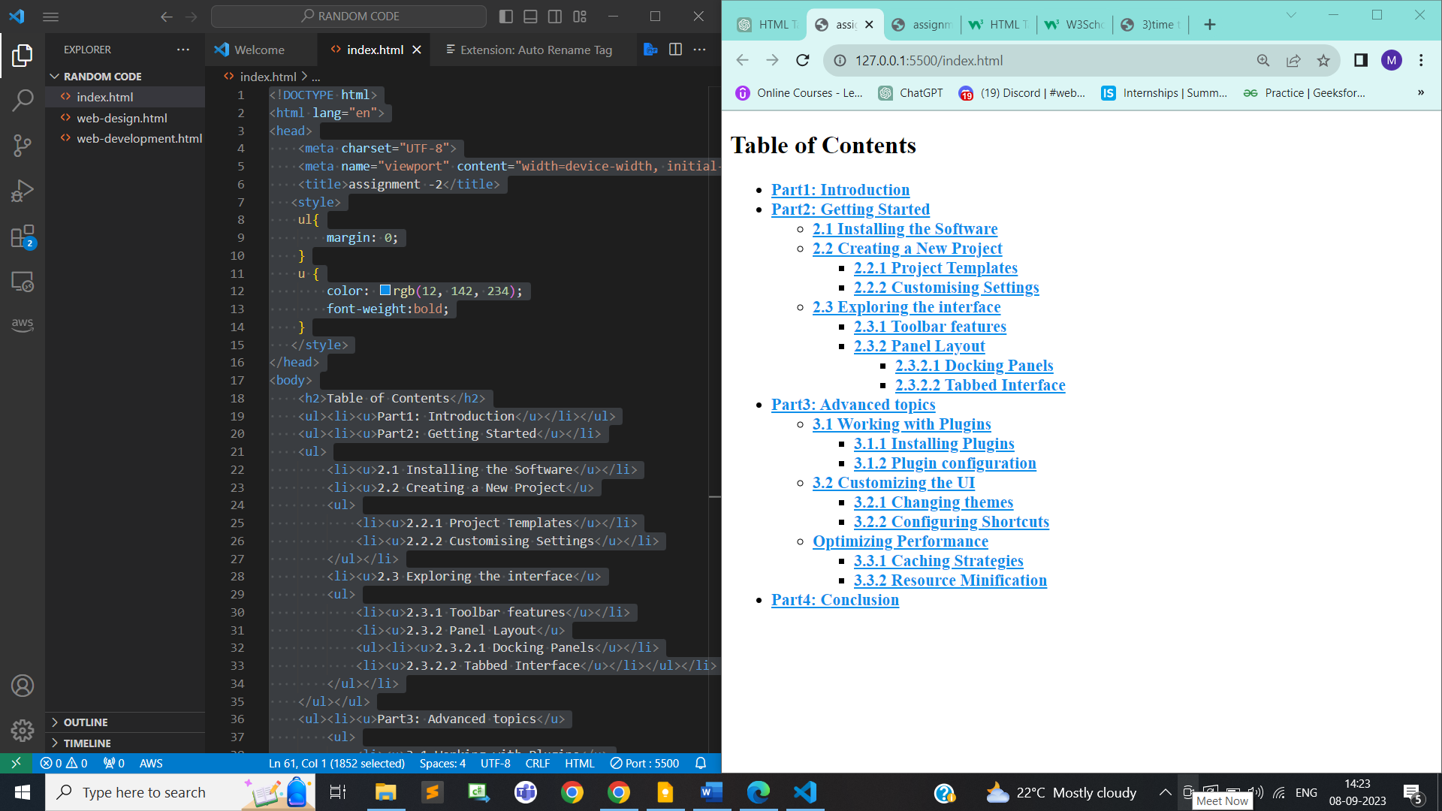

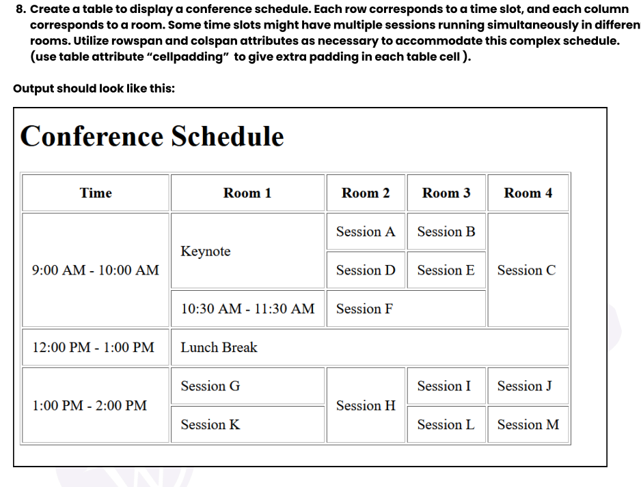

<!DOCTYPE html>

<html lang="en">

<head>

    <meta charset="UTF-8">

    <meta name="viewport" content="width=device-width, initial-scale=1.0">

    <title>assignment-2(Table)</title>

</head>

<body>

    <h2>Conference Schedule</h2>

    <table cellpadding="5" border="1">

        <tr>

            <th>Time</th>

            <th>Room 1</th>

            <th>Room 2</th>

            <th>Room 3</th>

            <th>Room 4</th>

        </tr>

        <tr><td rowspan="3">9.00 AM - 10.00 AM</td>

        <td rowspan="2">Keynote</td>

        <td>session A</td>

        <td>session B</td>

        <td rowspan="3">section C</td></tr>

        <tr><td>session D</td>

        <td>session E</td></tr>

        <tr><td>10.30 AM - 11.30 AM</td>

        <td colspan="2">session F</td></tr>

        <tr><td>12.00 PM - 1.00 PM</td>

        <td colspan="4">Lunch Break</td></tr>

        <tr><td rowspan="2">1.00 PM - 2.00 PM</td>

        <td>session G</td>

        <td rowspan="2">session H</td>

        <td>session I</td>

        <td>session J</td></tr>

        <tr><td>session K</td>

        <td>session L</td>

        <td>session M</td></tr>

    </table>

</body>

</html>

**Output:**

